**Code#1**

**#include<iostream>**

**using namespace std;**

**class worker**

**{**

**private:**

**char name[20];**

**int hours;**

**int days;**

**int salaray;**

**int month;**

**public:**

**void getdata()**

**{**

**cout<<"enter name:"<<endl;**

**cin>>name;**

**cout<<"enter hours:"<<endl;**

**cin>>hours;**

**cout<<"enter days:"<<endl;**

**cin>>days;**

**cout<<"enter salaray:"<<endl;**

**cin>>salaray;**

**cout<<"enter months:"<<endl;**

**cin>>month;**

**}**

**void showdata()**

**{**

**cout<<"\n"<<name<<endl;**

**if(hours<140)**

**{**

**cout<<"500RS deduct from your salaray per hour:"<<endl;**

**salaray=salaray-(500*days);**

**cout<<"your payment will be each month is RS: "<<salaray<<" per "<<hours<<" of working "<<endl;**

**cout<<"\nif you will continue like this tha your annual payment will be RS:"<<endl;**

**salaray=salaray*month;**

**cout<<salaray<<endl;**

**}**

**else if(hours>=140 && hours<228 ){**

**cout<<"your salary will be reamin same:"<<endl;**

**salaray=salaray;**

**cout<<"your payment will be each month is RS: "<<salaray<<" per "<<hours<<" of working "<<endl;**

**cout<<"\nif you will continue like this tha your annual payment will be RS:"<<endl;**

**salaray=salaray*month;**

**cout<<salaray<<endl;**

**}**

**else if(hours>=228){**

**cout<<"your salary increase for working 3 hours each day(1000RS per hours each day):"<<endl;**

**salaray=salaray+((1000/3)*days);**

**cout<<"your payment will be each month is RS: "<<salaray<<" per "<<hours<<" of working "<<endl;**

**cout<<"\nif you will continue like this tha your annual payment will be:"<<endl;**

**salaray=salaray*month;**

**cout<<salaray<<endl;**

**}**

**else**

**cout<<"invalid:"<<endl;**

**}**

**};**

**int main()**

**{**

**cout<<"140hours in one month = 4.6 hours per day:"<<endl;**

**cout<<"salary will be deducted if hours are < 140hours:"<<endl;**

**cout<<"228hours in one month = 7.6 hours per day 3hours extra:"<<endl;**

**cout<<"for over time working your salary will be increases if hours at the end of month is=228hours:"<<endl;**

**cout<<"--------------------------------------------------------------------------------------------"<<endl;**

**char check='y';**

**worker w;**

**while(check=='y'|| check=='Y')**

**{**

**w.getdata();**

**w.showdata();**

**cout<<"\n to add an other worker salaray details(Y/N):"<<endl;**

**cin>>check;**

**}**

**return 0;**

**}**

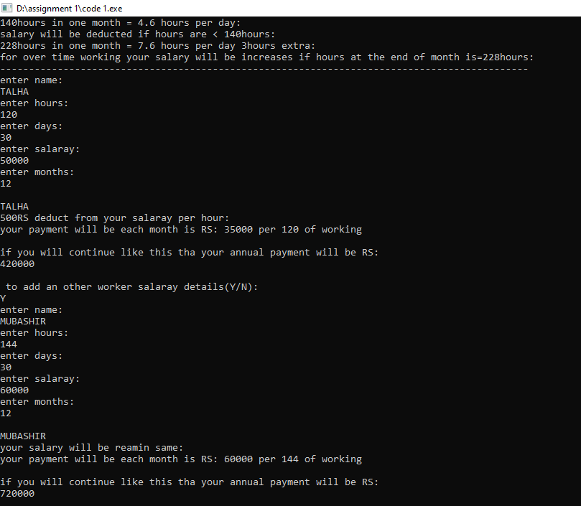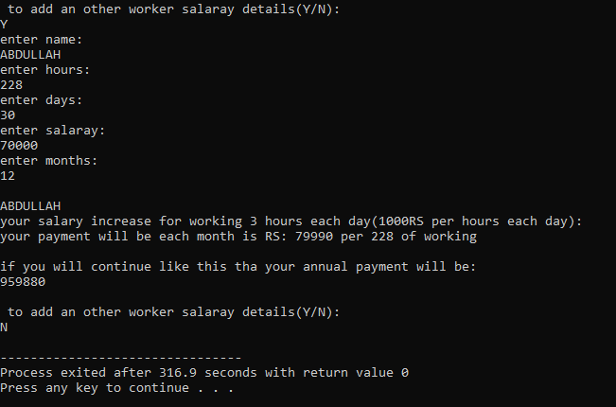**OUTPUT:-**

**CODE#2**

**#include <iostream>**

**#include <string>**

**using namespace std ;**

**class event**

**{**

**string project1;**

**string project2;**

**string project3;**

**string task1;**

**string task2;**

**string task3;**

**int point1;**

**int point2;**

**int point3;**

**public:**

**event()**

**{**

**project1="-";**

**project2="-";**

**project3="-";**

**task1="-";**

**task2="-";**

**task3="-";**

**point1=0;**

**point2=0;**

**point3=0;**

**}**

**void setdata(string p1,string p2,string p3,string t1,string t2,string t3)**

**{**

**project1=p1;**

**project2=p2;**

**project3=p3;**

**task1=t1;**

**task2=t2;**

**task3=t3;**

**}**

**int select_details()**

**{**

**string detail1="unique_idea";**

**string detail2="exisiting_idea";**

**string detail3="multi_social_needs";**

**string detail4="one_need";**

**string detail5="less_expensive";**

**if(task1==detail1 || task1==detail3)**

**{**

**cout<<"FIRST POSITION GROUP 1:"<<endl;**

**point1=point1+2;**

**}**

**else if(task1==detail2|| task1==detail4 || task1==detail5)**

**{**

**cout<<"SECOND POSITION GROUP 1:"<<endl;**

**point1=point1+1;**

**}**

**else if(task1==detail2|| task1==detail4 )**

**{**

**cout<<"THIRD POSITION GROUP 1:"<<endl;**

**point1=point1+1;**

**}**

**else**

**{**

**point1=point1+0;**

**}**

**if(task2==detail1 || task2==detail3){**

**cout<<"FIRST POSITION GROUP 2:"<<endl;**

**point2=point2+2;**

**}**

**else if(task2==detail2|| task2==detail4 || task2==detail5)**

**{**

**cout<<"SECOND POSITION GROUP 2:"<<endl;**

**point2=point2+1;**

**}**

**else if(task2==detail2|| task2==detail4 )**

**{**

**cout<<"THIRD POSITION GROUP 2:"<<endl;**

**point2=point2+1;**

**}**

**else**

**{**

**cout<<"THIRD POSITION GROUP 2:"<<endl;**

**point2=point2+0;**

**}**

**if(task3==detail1 || task3==detail3)**

**{**

**cout<<"FIRST POSITION GROUP 3:"<<endl;**

**point3=point3+2;**

**}**

**else if(task3==detail2|| task3==detail4 || task3==detail5)**

**{**

**cout<<"SECOND POSITION GROUP 3:"<<endl;**

**point3=point3+1;**

**}**

**else if(task3==detail2|| task3==detail4 )**

**{**

**cout<<"THIRD POSITION GROUP 3:"<<endl;**

**point3=point3+1;**

**}**

**else**

**{**

**cout<<"THIRD POSITION GROUP 3:"<<endl;**

**point3=point3+0;**

**}**

**}**

**int displayresults()**

**{**

**cout<<"\nPOINTS OF GROUP 1 IS:"<<point1<<endl;**

**cout<<"POINTS OF GROUP 2 IS:"<<point2<<endl;**

**cout<<"POINTS OF GROUP 3 IS:"<<point3<<endl;**

**if(point1>point2 && point1>point2)**

**{**

**cout<<"\nCONGRATULATIONS GROUP 1 WINNER:"<<endl;**

**}**

**else if(point2>point1 && point2>point3)**

**{**

**cout<<"\nCONGRATULATIONS GROUP 2 WINNER:"<<endl;**

**}**

**else**

**{**

**cout<<"\nCONGRATULATIONS GROUP 3 WINNER:"<<endl;**

**}**

**}**

**};**

**int main ()**

**{**

**cout<<"POINTS DISTRIBUTION DETAILS:"<<endl;**

**cout<<"ON THE BASIS OF FOLLOWING SPECIALITY"<<endl;**

**cout<<"unique_idea -> 2 points"<<endl;**

**cout<<"multi_social_needs -> 2 points"<<endl;**

**cout<<"exisiting_idea -> 1 point"<<endl;**

**cout<<"one_need-> 1point"<<endl;**

**cout<<"less_expensive->1point"<<endl;**

**cout<<"** **for other -> 0 points"<<endl;**

**event &e1=*(new event);**

**string project1,project2,project3;**

**string task1,task2,task3;**

**cout<<"\nENTER THE NAME OF YOUR PROJECT & SPECIALITY GROUP1:"<<endl;**

**cin>>project1>>task1;**

**cout<<"ENTER THE NAME OF YOUR PROJECT & SPECIALITY GROUP2:"<<endl;**

**cin>>project2>>task2;**

**cout<<"ENTER THE NAME OF YOUR PROJECT & SPECIALITY GROUP3:"<<endl;**

**cin>>project3>>task3;**

**e1.setdata(project1,project2,project3,task1,task2,task3);**

**e1.select_details();**

**e1.displayresults();**

**return 0;**

**}**

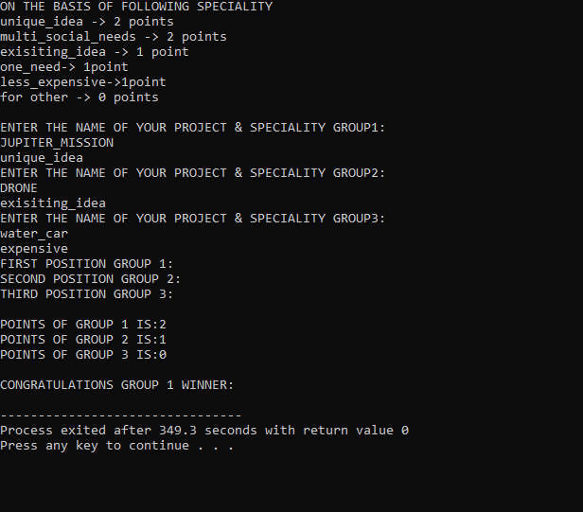**OUTPUT:-**

**CODE#3**

**#include<iostream>**

**using namespace std;**

**class tollbooth**

**{**

**private:**

**int countc1=0;**

**int carpass;**

**int countc2=0;**

**int bikepass;**

**int countc3=0;**

**int busspass;**

**int total=0;**

**public:**

**tollbooth():countc1(0),countc2(0),countc3(0),total(0)**

**{}**

**public:**

**void car_pass()**

**{**

**cout<<"\nenter the no.of times car passes:"<<endl;**

**cin>>carpass;**

**for(int i=1; i<=carpass; i++)**

**{**

**countc1++;**

**total=total+50;**

**}**

**}**

**void bike_pass()**

**{**

**cout<<"enter the no.of times bike passes:"<<endl;**

**cin>>bikepass;**

**for(int i=1; i<=bikepass; i++)**

**{**

**countc2++;**

**total=total+20;**

**}**

**}**

**void bus_pass()**

**{**

**cout<<"enter the no.of times buss passes:"<<endl;**

**cin>>busspass;**

**for(int i=1; i<=busspass; i++)**

**{**

**countc3++;**

**total=total+100;**

**}**

**}**

**void display_data()**

**{**

**cout<<"CAR PASSES:"<<countc1<<endl;**

**cout<<"BIKE PASSES:"<<countc2<<endl;**

**cout<<"BUS PASSES:"<<countc3<<endl;**

**cout<<"TOTAL REVENUE COLLECTED:"<<total<<endl;**

**}**

**};**

**int main()**

**{**

**cout<<" _________________________________"<<endl;**

**cout<<"| |"<<endl;**

**cout<<"| WELCOME TO |"<<endl;**

**cout<<"| TOLLBOOTH STATION |"<<endl;**

**cout<<"|_________________________________|"<<endl;**

**tollbooth b1;**

**b1.car_pass();**

**b1.bike_pass();**

**b1.bus_pass();**

**b1.display_data();**

**return 0;**

**}**

**OUTPUT:-**

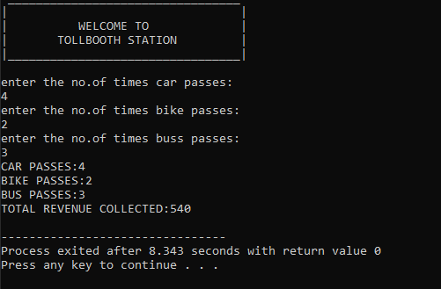

**CODE#4**

**#include<iostream>**

**using namespace std;**

**class time**

**{**

**private:**

**int hour;**

**int min;**

**int sec;**

**public:**

**time():hour(0),min(0),sec(0)**

**{}**

**time(int hr ,int mn , int se):hour(hr),min(mn),sec(se)**

**{}**

**void gettime()**

**{**

**cout<<"\nENTER HOURS:"<<endl;cin>>hour;**

**cout<<"ENTER MINUTES:"<<endl;cin>>min;**

**cout<<"ENTER SECONDS:"<<endl;cin>>sec;**

**}**

**void showtime()const**

**{**

**cout<<hour<<":"<<min<<":"<<sec;**

**}**

**time operator + (time)const;**

**time operator - (time)const;**

**};**

**time time::operator + (time t2)const**

**{**

**int h=hour+t2.hour;**

**int m=min+t2.min;**

**int s=sec+t2.sec;**

**if(s>=60)**

**{**

**s-=60;**

**m++;**

**}**

**if(m>=60)**

**{**

**m-=60;**

**h++;**

**if(h>=24)**

**{**

**h-=24;**

**}**

**}**

**return time(h,m,s);**

**}**

**time time::operator - (time t2)const**

**{**

**int h=hour-t2.hour;**

**int m=min-t2.min;**

**int s=sec-t2.sec;**

**if(s<=0)**

**{**

**s+=0;**

**m--;**

**}**

**if(m<=0)**

**{**

**m+=0;**

**h--;**

**}**

**if(h>=24)**

**{**

**h-=24;**

**}**

**return time(h,m,s);**

**}**

**int main()**

**{**

**cout<<"CLOCK"<<endl;**

**cout<<" ______________"<<endl;**

**cout<<" | |"<<endl;**

**cout<<" | 12 |"<<endl;**

**cout<<" | |"<<endl;**

**cout<<" | 9 L 3 |"<<endl;**

**cout<<" | |"<<endl;**

**cout<<" | 6 |"<<endl;**

**cout<<" |______________|"<<endl;**

**time t1,t3,t4;**

**t1.gettime();**

**time t2(2,24,25);**

**t3=t1+t2;**

**t4=t1-t2;**

**cout<<"t1 = ";t1.showtime();cout<<endl;**

**cout<<"t2 = ";t2.showtime();cout<<endl;**

**int n;**

**cout<<"\nPRESS 1 FOR ADD TIME PRESS 2 FOR SUBTRACT TIME:"<<endl;**

**cin>>n;**

**if(n==1)**

**{**

**cout<<"\nt3 = ";t3.showtime();cout<<endl;**

**}**

**else if(n==2)**

**{**

**cout<<"\nt4 = ";t4.showtime();cout<<endl;**

**}**

**else**

**cout<<"wrong input:"<<endl;**

**return 0;**

**}**

**OUTPUT:-**

**ADDITION:-**

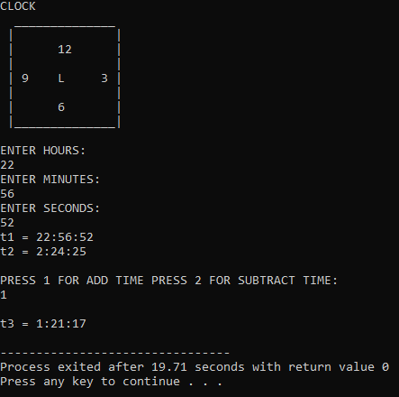

**SUBTRACTION:-**

